**Lab-1**-Genetic Algorithm for Optimization Problems

**Code:**

#1

import random

def fitness_function(x):

return x**2

population_size = 500

mutation_rate = 0.01

crossover_rate = 0.7

generations = 5

lower_bound = -10

upper_bound = 10

def create_population():

population = [random.uniform(lower_bound, upper_bound) for _ in range(population_size)]

return population

def evaluate_fitness(population):

fitness_scores = [fitness_function(individual) for individual in population]

return fitness_scores

def select(population, fitness_scores):

total_fitness = sum(fitness_scores)

selection_probs = [score / total_fitness for score in fitness_scores]

selected = random.choices(population, weights=selection_probs, k=2)

return selected

def crossover(parent1, parent2):

if random.random() < crossover_rate:

# Crossover at a single point (since we're dealing with floats, we'll use averaging)

child1 = (parent1 + parent2) / 2

child2 = (parent1 + parent2) / 2

else:

child1, child2 = parent1, parent2

return child1, child2

def mutate(individual):

if random.random() < mutation_rate:

mutation_value = random.uniform(-1, 1)

individual += mutation_value

return max(min(individual, upper_bound), lower_bound)

def genetic_algorithm():

population = create_population()

for generation in range(generations):

fitness_scores = evaluate_fitness(population)

best_fitness = max(fitness_scores)

best_individual = population[fitness_scores.index(best_fitness)]

new_population = []

while len(new_population) < population_size:

parent1, parent2 = select(population, fitness_scores)

child1, child2 = crossover(parent1, parent2)

child1 = mutate(child1)

child2 = mutate(child2)

new_population.append(child1)

if len(new_population) < population_size:

new_population.append(child2)

population = new_population

print(f"Generation {generation + 1}: Best Fitness = {best_fitness}, Best Individual = {best_individual}")

return best_individual, best_fitness

best_solution, best_fitness = genetic_algorithm()

print(f"\nBest solution found: {best_solution} with fitness: {best_fitness}")

print("P Manya")

print("1BM22CS187")

**Output:**

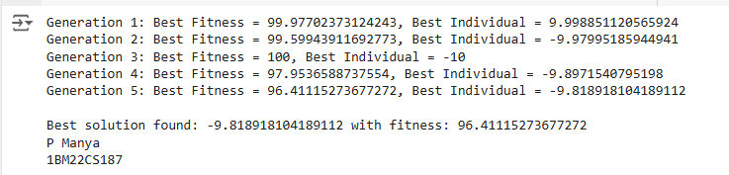

**Lab-2**-Particle Swarm Optimization for Function Optimization

**Code:**

#2

import numpy as np

# Define the Rastrigin function

def rastrigin(x):

A = 10

return A * len(x) + sum([xi**2 - A * np.cos(2 * np.pi * xi) for xi in x])

class Particle:

def __init__(self, dim):

self.position = np.random.uniform(-5.12, 5.12, dim)

self.velocity = np.random.uniform(-1, 1, dim)

self.best_position = np.copy(self.position)

self.best_value = rastrigin(self.position)

def update_velocity(self, global_best_position, inertia_weight, cognitive_coef, social_coef):

r1, r2 = np.random.rand(2)

cognitive_velocity = cognitive_coef * r1 * (self.best_position - self.position)

social_velocity = social_coef * r2 * (global_best_position - self.position)

self.velocity = inertia_weight * self.velocity + cognitive_velocity + social_velocity

def update_position(self):

self.position += self.velocity

# Keep the particle within the bounds

self.position = np.clip(self.position, -5.12, 5.12)

# Update the best position if necessary

current_value = rastrigin(self.position)

if current_value < self.best_value:

self.best_value = current_value

self.best_position = np.copy(self.position)

def pso(num_particles, dim, num_iterations):

inertia_weight = 0.7

cognitive_coef = 1.5

social_coef = 1.5

# Initialize particles

particles = [Particle(dim) for _ in range(num_particles)]

global_best_position = particles[0].best_position

global_best_value = particles[0].best_value

# Main PSO loop

for _ in range(num_iterations):

for particle in particles:

particle.update_velocity(global_best_position, inertia_weight, cognitive_coef, social_coef)

particle.update_position()

# Update global best

if particle.best_value < global_best_value:

global_best_value = particle.best_value

global_best_position = particle.best_position

return global_best_position, global_best_value

# User input for parameters

num_particles = int(input("Enter the number of particles: "))

dim = int(input("Enter the number of dimensions: "))

num_iterations = int(input("Enter the number of iterations: "))

# Run PSO

best_position, best_value = pso(num_particles, dim, num_iterations)

# Output the best position and value

print(f"Best Position: {best_position}")

print(f"Best Value: {best_value}")

print("P Manya")

print("1BM22CS187")

**Output:**

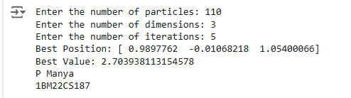

**Lab-3**-Ant Colony Optimization for the Traveling Salesman Problem

**Code:**

#3

import numpy as np

import random

class AntColony:

def __init__(self, cities, num_ants, alpha, beta, rho, q0, iterations):

self.cities = cities

self.num_ants = num_ants

self.alpha = alpha

self.beta = beta

self.rho = rho # pheromone evaporation rate

self.q0 = q0 # exploration vs. exploitation parameter

self.iterations = iterations

self.distance_matrix = self.calculate_distance_matrix()

self.pheromone = np.ones(self.distance_matrix.shape) / len(cities)

def calculate_distance_matrix(self):

num_cities = len(self.cities)

distance_matrix = np.zeros((num_cities, num_cities))

for i in range(num_cities):

for j in range(num_cities):

distance_matrix[i][j] = np.linalg.norm(np.array(self.cities[i]) - np.array(self.cities[j]))

return distance_matrix

def select_next_city(self, current_city, visited):

probabilities = []

for next_city in range(len(self.cities)):

if next_city not in visited:

pheromone = self.pheromone[current_city][next_city] ** self.alpha

heuristic = (1 / self.distance_matrix[current_city][next_city]) ** self.beta

probabilities.append(pheromone * heuristic)

else:

probabilities.append(0)

probabilities = np.array(probabilities)

probabilities /= probabilities.sum() # Normalize

return np.random.choice(range(len(self.cities)), p=probabilities)

def construct_solution(self):

for _ in range(self.num_ants):

visited = [0]

current_city = 0

for _ in range(len(self.cities) - 1):

current_city = self.select_next_city(current_city, visited)

visited.append(current_city)

visited.append(0) # Return to starting city

yield visited

def update_pheromones(self, solutions):

self.pheromone *= (1 - self.rho) # Evaporation

for solution in solutions:

distance = self.calculate_tour_length(solution)

for i in range(len(solution) - 1):

self.pheromone[solution[i]][solution[i + 1]] += 1 / distance

def calculate_tour_length(self, tour):

return sum(self.distance_matrix[tour[i]][tour[i + 1]] for i in range(len(tour) - 1))

def run(self):

best_solution = None

best_length = float('inf')

for _ in range(self.iterations):

solutions = list(self.construct_solution())

self.update_pheromones(solutions)

for solution in solutions:

length = self.calculate_tour_length(solution)

if length < best_length:

best_length = length

best_solution = solution

return best_solution, best_length

def main():

# User input for cities

num_cities = int(input("Enter the number of cities: "))

cities = []

for i in range(num_cities):

x, y = map(float, input(f"Enter coordinates for city {i + 1} (x y): ").split())

cities.append((x, y))

# Parameters for ACO

num_ants = int(input("Enter the number of ants: "))

alpha = float(input("Enter the importance of pheromone (alpha): ")) # Importance of pheromone

beta = float(input("Enter the importance of heuristic (beta): "))

rho = float(input("Enter the pheromone evaporation rate (rho): "))

q0 = float(input("Enter the exploration parameter (q0): "))

iterations = int(input("Enter the number of iterations: "))

# Run the ACO algorithm

aco = AntColony(cities, num_ants, alpha, beta, rho, q0, iterations)

best_solution, best_length = aco.run()

print("Best solution:", best_solution)

print("Best tour length:", best_length)

if __name__ == "__main__":

main()

print("P Manya")

print("1BM22CS187")

**Output:**

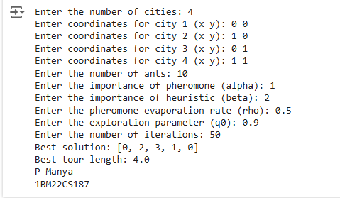

**Lab-4**-Cuckoo Search (CS)

**Code:**

#4

import numpy as np

import random

# Step 1: Define the Problem (Optimization Function)

def objective_function(x):

# Example: Sphere function (minimization problem)

return sum(x**2)

# Step 2: Initialize Parameters

def cuckoo_search(num_nests, max_iter, pa, dim, lower_bound, upper_bound):

# Initialize nests randomly within the bounds

nests = np.random.uniform(low=lower_bound, high=upper_bound, size=(num_nests, dim))

# Evaluate fitness of each nest

fitness = np.apply_along_axis(objective_function, 1, nests)

# Track the best solution found

best_fitness = np.min(fitness)

best_nest = nests[np.argmin(fitness)]

# Step 3: Iterate the process

for iter in range(max_iter):

# Generate new solutions using Lévy flights

new_nests = np.copy(nests)

for i in range(num_nests):

# Lévy flight (random walk)

step_size = np.random.normal(0, 1, dim) * (np.abs(np.random.normal(0, 1, dim)) ** (1/2))

new_nests[i] = nests[i] + step_size

# Boundary check (Keep the nest within bounds)

new_nests[i] = np.clip(new_nests[i], lower_bound, upper_bound)

# Evaluate fitness of new nests

new_fitness = np.apply_along_axis(objective_function, 1, new_nests)

# Step 4: Abandon Worst Nests and Replace

for i in range(num_nests):

if new_fitness[i] < fitness[i]: # If new nest is better

nests[i] = new_nests[i]

fitness[i] = new_fitness[i]

# Discovering worst nests and abandon them with probability pa

if random.random() < pa:

abandon_indices = np.argsort(fitness)[:int(num_nests * 0.25)] # abandon worst 25%

nests[abandon_indices] = np.random.uniform(low=lower_bound, high=upper_bound,

size=(len(abandon_indices), dim))

fitness[abandon_indices] = np.apply_along_axis(objective_function, 1,

nests[abandon_indices])

# Track best solution so far

current_best_fitness = np.min(fitness)

current_best_nest = nests[np.argmin(fitness)]

if current_best_fitness < best_fitness:

best_fitness = current_best_fitness

best_nest = current_best_nest

# Output the current best solution (optional)

print(f"Iteration {iter + 1}/{max_iter}, Best Fitness: {best_fitness}")

return best_nest, best_fitness

# Step 5: User Input for Parameters

if __name__ == "__main__":

# User input for parameters

num_nests = int(input("Enter number of nests: "))

max_iter = int(input("Enter number of iterations: "))

pa = float(input("Enter probability of discovery (pa) [0, 1]: "))

dim = int(input("Enter the number of dimensions: "))

lower_bound = float(input("Enter lower bound for search space: "))

upper_bound = float(input("Enter upper bound for search space: "))

# Run the Cuckoo Search Algorithm

best_solution, best_fitness = cuckoo_search(num_nests, max_iter, pa, dim, lower_bound, upper_bound)

# Output the best solution found

print(f"\nBest Solution: {best_solution}")

print(f"Best Fitness: {best_fitness}")

print("P Manya")

print("1BM22CS187")

**Output:**

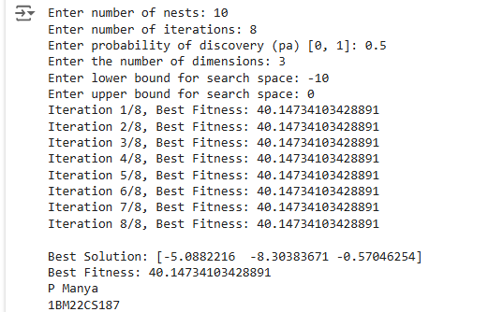

**Lab-5**-Grey Wolf Optimizer (GWO

**Code:**

#5

import numpy as np

# Define the Grey Wolf Optimizer (GWO) algorithm

class GreyWolfOptimizer:

def __init__(self, func, dim, num_wolves, max_iter, lb, ub):

"""

:param func: The objective function to optimize (should take a numpy array as input)

:param dim: The dimension of the search space

:param num_wolves: The number of wolves (population size)

:param max_iter: The maximum number of iterations

:param lb: Lower bound of the search space

:param ub: Upper bound of the search space

"""

self.func = func

self.dim = dim

self.num_wolves = num_wolves

self.max_iter = max_iter

self.lb = lb

self.ub = ub

self.alpha_pos = np.zeros(dim)

self.beta_pos = np.zeros(dim)

self.delta_pos = np.zeros(dim)

self.alpha_score = float("inf")

self.beta_score = float("inf")

self.delta_score = float("inf")

# Initialize the positions of the wolves randomly

self.positions = np.random.rand(self.num_wolves, self.dim) * (self.ub - self.lb) + self.lb

def fitness(self, position):

"""Calculate the fitness value of a wolf"""

return self.func(position)

def update_position(self, wolf, alpha_pos, beta_pos, delta_pos, a, A, C):

"""Update the position of a wolf based on the positions of alpha, beta, and delta wolves"""

# Update for alpha, beta, and delta wolves, using the respective A and C values

D_alpha = np.abs(C[0] * alpha_pos - wolf)

D_beta = np.abs(C[1] * beta_pos - wolf)

D_delta = np.abs(C[2] * delta_pos - wolf)

# Updated positions

X1 = alpha_pos - A[0] * D_alpha

X2 = beta_pos - A[1] * D_beta

X3 = delta_pos - A[2] * D_delta

# New position is the average of the three updated positions

new_position = (X1 + X2 + X3) / 3

return new_position

def optimize(self):

"""Run the optimization process"""

for t in range(self.max_iter):

a = 2 - t * (2 / self.max_iter) # Declining a over iterations

A = 2 * a * np.random.rand(self.num_wolves, self.dim) - a # Random vector for wolves' A values

C = 2 * np.random.rand(self.num_wolves, self.dim) # Random vector for wolves' C values

# Loop over each wolf

for i in range(self.num_wolves):

# Evaluate fitness of each wolf

fitness_value = self.fitness(self.positions[i])

# Update alpha, beta, and delta wolves

if fitness_value < self.alpha_score:

self.alpha_score = fitness_value

self.alpha_pos = self.positions[i]

elif fitness_value < self.beta_score:

self.beta_score = fitness_value

self.beta_pos = self.positions[i]

elif fitness_value < self.delta_score:

self.delta_score = fitness_value

self.delta_pos = self.positions[i]

# Update the positions of all wolves

for i in range(self.num_wolves):

self.positions[i] = self.update_position(self.positions[i], self.alpha_pos, self.beta_pos,

self.delta_pos, a, A[i], C[i])

# Optionally, print progress

if t % 1 == 0: # Adjust the interval for printing

print(f"Iteration {t}/{self.max_iter}, Best fitness: {self.alpha_score}")

return self.alpha_pos, self.alpha_score

# Example usage:

def objective_function(x):

"""A simple objective function: Sphere function"""

return np.sum(x ** 2)

# User input for parameters

dim = int(input("Enter the number of dimensions: "))

num_wolves = int(input("Enter the number of wolves: "))

max_iter = int(input("Enter the maximum number of iterations: "))

lb = float(input("Enter the lower bound of the search space: "))

ub = float(input("Enter the upper bound of the search space: "))

# Initialize and run the GWO algorithm

optimizer = GreyWolfOptimizer(func=objective_function, dim=dim, num_wolves=num_wolves,

max_iter=max_iter, lb=lb, ub=ub)

best_position, best_score = optimizer.optimize()

# Output the best solution found

print(f"\nBest Position: {best_position}")

print(f"Best Score: {best_score}")

print("P Manya")

print("1BM22CS187")

**Output:**

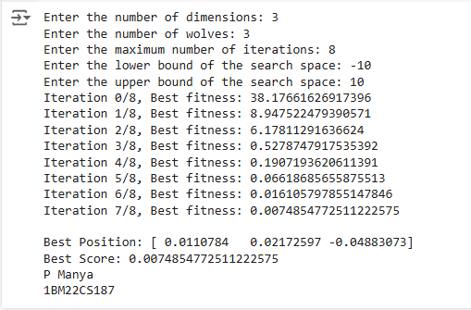

**Lab-6**-Parallel Cellular Algorithms and Programs

**Code:**

#6

import numpy as np

import random

import math

import concurrent.futures

# Define the Rastrigin function (objective function to optimize)

def rastrigin_function(x):

A = 10

return A * len(x) + sum([(xi ** 2 - A * math.cos(2 * math.pi * xi)) for xi in x])

# Initialize the population of cells (solutions) randomly

def initialize_population(num_cells, grid_size):

population = []

for _ in range(num_cells):

cell = np.random.uniform(-5.12, 5.12, grid_size) # Rastrigin function bounds [-5.12, 5.12]

population.append(cell)

return population

# Evaluate the fitness of a cell (solution)

def evaluate_fitness(cell):

return rastrigin_function(cell)

# Function to update the state of each cell based on its neighbors

def update_cell_state(cell, neighbors, grid_size):

# For simplicity, we'll use an average of the neighbors' states (here it's just a random update)

best_neighbor = min(neighbors, key=lambda n: evaluate_fitness(n))

# Move towards the best neighbor in the fitness landscape

new_cell = cell + 0.1 * (best_neighbor - cell)

return np.clip(new_cell, -5.12, 5.12) # Clamping to the function's bounds

# Parallelized function to perform the main update step for each cell

def update_population(population, grid_size):

updated_population = []

# Parallelize the update step for all cells in the population

with concurrent.futures.ThreadPoolExecutor() as executor:

future_to_cell = {}

for i in range(len(population)):

# Get the neighbors (simple example: using adjacent cells)

neighbors = population[max(i - 1, 0):min(i + 2, len(population))]

future_to_cell[executor.submit(update_cell_state, population[i], neighbors, grid_size)] = population[i]

# Gather the results

for future in concurrent.futures.as_completed(future_to_cell):

updated_population.append(future.result())

return updated_population

# Main function to perform the optimization

def parallel_cellular_algorithm(num_cells, grid_size, num_iterations):

# Step 1: Initialize Population

population = initialize_population(num_cells, grid_size)

best_solution = None

best_fitness = float('inf')

# Step 2: Main Loop (Iterate for a fixed number of iterations)

for iteration in range(num_iterations):

# Step 3: Evaluate fitness of all cells

fitness_scores = [evaluate_fitness(cell) for cell in population]

# Track the best solution

min_fitness = min(fitness_scores)

if min_fitness < best_fitness:

best_fitness = min_fitness

best_solution = population[fitness_scores.index(min_fitness)]

print(f"Iteration {iteration + 1}/{num_iterations}, Best Fitness: {best_fitness}")

# Step 4: Update population based on neighbors

population = update_population(population, grid_size)

# Output the best solution found

return best_solution, best_fitness

# Main function to handle user input and execution

if __name__ == "__main__":

# Get user input for parameters

num_cells = int(input("Enter the number of cells: "))

grid_size = int(input("Enter the grid size (dimension of each solution): "))

num_iterations = int(input("Enter the number of iterations: "))

# Run the Parallel Cellular Algorithm

best_solution, best_fitness = parallel_cellular_algorithm(num_cells, grid_size, num_iterations)

# Output the best solution found

print("\nOptimization complete!")

print("Best Solution Found:", best_solution)

print("Best Fitness:", best_fitness)

print("P Manya")

print("1BM22CS187")

**Output:**

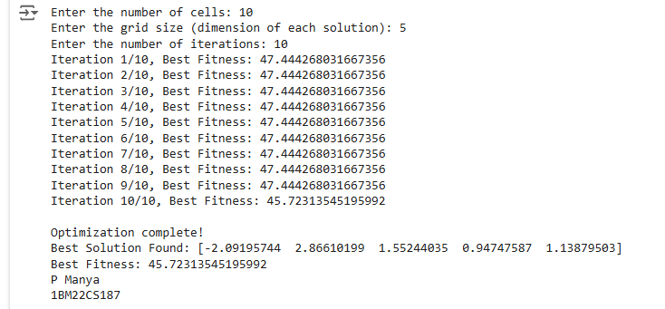

**Lab-7**-Optimization via Gene Expression Algorithms

**Code:**

#7

import numpy as np

# Step 1: Define the Problem

# Define your mathematical optimization function here

# Example: Minimize the function f(x) = x^2 - 4x + 4 (a simple quadratic function)

def objective_function(x):

return x**2 - 4*x + 4

# Step 2: Initialize Parameters

def initialize_parameters():

population_size = int(input("Enter population size: ")) # Number of individuals in the population

num_genes = int(input("Enter number of genes: ")) # Number of genes in each individual

mutation_rate = float(input("Enter mutation rate (0 to 1): ")) # Probability of mutation

crossover_rate = float(input("Enter crossover rate (0 to 1): ")) # Probability of crossover

num_generations = int(input("Enter number of generations: ")) # Number of generations

return population_size, num_genes, mutation_rate, crossover_rate, num_generations

# Step 3: Initialize Population

def initialize_population(population_size, num_genes):

population = np.random.uniform(low=-5, high=5, size=(population_size, num_genes))

return population

# Step 4: Evaluate Fitness

def evaluate_fitness(population, objective_function):

fitness = np.apply_along_axis(objective_function, 1, population) # Apply the objective function to each individual

return fitness

# Step 5: Selection (Tournament Selection)

def selection(population, fitness, num_parents):

parents = []

for _ in range(num_parents):

tournament = np.random.choice(population.shape[0], size=3, replace=False) # Select 3 individuals for tournament

tournament_fitness = fitness[tournament]

winner = tournament[np.argmin(tournament_fitness)] # Select the individual with the best fitness

parents.append(population[winner])

return np.array(parents)

# Step 6: Crossover (Single-point crossover)

def crossover(parents, crossover_rate):

num_parents = parents.shape[0]

offspring = []

for i in range(0, num_parents, 2):

if np.random.rand() < crossover_rate:

# Ensure that we have more than 1 gene to perform crossover

if parents.shape[1] > 1:

crossover_point = np.random.randint(1, parents.shape[1])

offspring1 = np.concatenate([parents[i, :crossover_point], parents[i+1, crossover_point:]])

offspring2 = np.concatenate([parents[i+1, :crossover_point], parents[i, crossover_point:]])

offspring.append(offspring1)

offspring.append(offspring2)

else:

# No crossover if there's only 1 gene

offspring.append(parents[i])

if i + 1 < num_parents:

offspring.append(parents[i + 1])

else:

offspring.append(parents[i])

if i + 1 < num_parents:

offspring.append(parents[i + 1])

return np.array(offspring)

# Step 7: Mutation

def mutation(offspring, mutation_rate):

for i in range(offspring.shape[0]):

for j in range(offspring.shape[1]):

if np.random.rand() < mutation_rate:

offspring[i, j] += np.random.normal(0, 0.1) # Apply Gaussian mutation

return offspring

# Step 8: Gene Expression (Translate Genes into Solutions)

def gene_expression(offspring):

# In this case, the genes are directly the solutions

return offspring

# Step 9: Iterate (Repeat the selection, crossover, mutation, and gene expression processes)

def run_ge_algorithm(objective_function):

population_size, num_genes, mutation_rate, crossover_rate, num_generations = initialize_parameters()

# Initialize population

population = initialize_population(population_size, num_genes)

# Start optimization process

best_solution = None

best_fitness = float('inf')

for generation in range(num_generations):

# Evaluate fitness

fitness = evaluate_fitness(population, objective_function)

# Track the best solution

min_fitness_idx = np.argmin(fitness)

if fitness[min_fitness_idx] < best_fitness:

best_fitness = fitness[min_fitness_idx]

best_solution = population[min_fitness_idx]

# Selection

parents = selection(population, fitness, population_size // 2)

# Crossover

offspring = crossover(parents, crossover_rate)

# Mutation

offspring = mutation(offspring, mutation_rate)

# Gene Expression (Directly apply the offspring as solutions)

population = gene_expression(offspring)

# Print the progress

print(f"Generation {generation + 1}: Best Fitness = {best_fitness}")

return best_solution, best_fitness

# Step 10: Output the Best Solution

best_solution, best_fitness = run_ge_algorithm(objective_function)

print(f"Best solution found: {best_solution}")

print(f"Best fitness value: {best_fitness}")

print("P Manya")

print("1BM22CS187")

**Output:**

